**Facebook Business Page:**

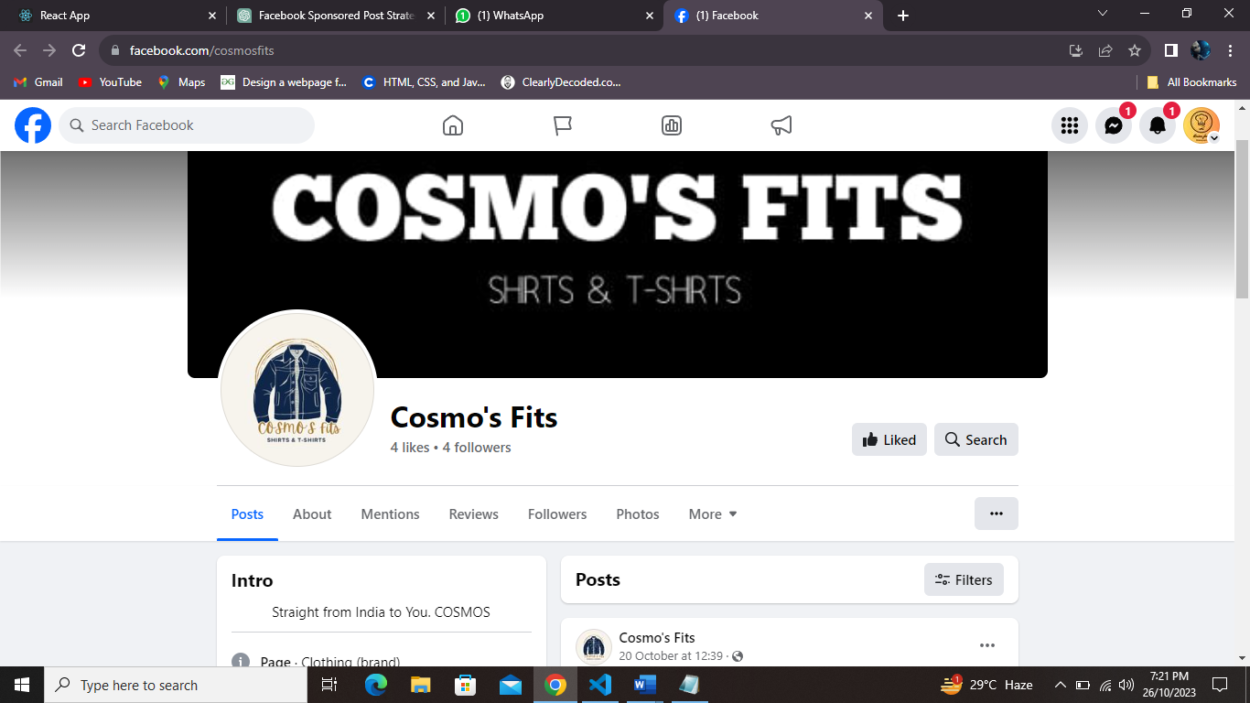

<https://www.facebook.com/cosmosfits/>